**Unit 3 - Uniform Acceleration**

**Table of Contents**

Instructional Goals 3

Student Learning Objectives 4

Uniform Acceleration: An Overview 4

Sequence 8

Unit Primer — Contrasting ‘Fast’ and ‘Slow’ Constant Motion 9

Apparatus 9

Lab 1 — Inclined Rail Motion (high-tech version) 10

Apparatus 10

Pre-Lab Discussion 10

Lab Performance Notes 10

Lab 1 — Inclined Rail Motion (low-tech version) 11

Apparatus 11

Pre-Lab Discussion 11

Lab Performance Notes 11

Post-Lab Discussion 11

Worksheet 1a, 1b, 1c — Non-Constant Velocity 12

Resources 12

Activity 1 — Pace Car 15

Resources 15

Performance Notes 15

Lab 1 Extension — Speeding Up, Slowing Down 17

Resources 17

Apparatus 17

Pre-Lab Discussion 17

Lab Performance Notes 18

Post-Lab Discussion 18

Class Discussion — Development of Kinematic Formulas 19

Worksheet 2 — Self-Driving Car 20

Resources 20

Activity 2 — Miniature Golf 23

Resources 23

Worksheet 3 — Uniform Acceleration Problems 24

Resources 24

Lab 2 — Free Fall 24

Resources 24

Apparatus 24

Pre-Lab Discussion 24

Lab Performance Notes 24

Post-Lab Discussion 25

Activity 3 — Simulating Lunar Drop 25

Resources 25

Worksheet 4 - Free Fall Practice 26

Resources 26

Activity 4 — Rocket Lander Game 26

Resources 26

The Model So Far 27

Resource Index 28

Unit 3 Worksheet 1a: Non-Constant Velocity 29

Unit 3 Worksheet 1b: Non-Constant Velocity 32

Unit 3 Worksheet 1c: Non-Constant Velocity 33

Unit 3 Activity 1: Pace Car 35

Unit 3 Lab 1 Extension: Speeding Up, Slowing Down 38

Unit 3 Worksheet 2: Self-Driving Car 44

Unit 3 Activity 2: Miniature Golf 48

Unit 3 Worksheet 3: Uniform Acceleration Problems 49

Unit 3 Lab 2: Free Fall 51

Unit 3 Activity 3: Simulating Lunar Drop 53

Unit 3 Worksheet 4: Free Fall Practice 54

Unit 3 Activity 4: Rocket Lander Game 56

Function Design with Extended Examples 57

# **Instructional Goals**

1. **Concepts of acceleration, average vs instantaneous velocity**

* Contrast graphs of objects undergoing constant velocity and uniform acceleration
* Define instantaneous velocity (slope of tangent to curve in x vs. t graph)
* Distinguish between instantaneous and average velocity
* Define acceleration, including its vector nature
* Motion map now includes acceleration vectors

1. **Multiple representations (graphical, algebraic, diagrammatic, computational)**

* Introduce stack of kinematic curves
  + position vs. time (slope of tangent = instantaneous velocity)
  + velocity vs. time (slope = acceleration, area under curve = change in position)
  + acceleration vs. time (area under curve = change in velocity)
* Relate various representations

1. **Differential Representations**

* Represent the motion of an object undergoing uniform acceleration using the functions next-x and next-v
* Apply computational models to an object undergoing free fall
* Reinforce the use of single and multiple argument functions to simulate motion.

1. **Analysis of Free Fall Motion**

* Apply the current model for the motion of an accelerating object to an object undergoing free fall

1. **Uniformly Accelerating Particle Model**

* Domain and kinematics properties
* Derive algebraic relationships from x vs t and v vs t graphs

# 

# 

# **Student Learning Objectives**

1. UA1: I can use position-time, velocity-time and acceleration-time graphs to represent the motion of an object moving with a uniform acceleration.
2. UA2: I can represent the motion of an object moving with a uniform acceleration using velocity and acceleration vectors on a motion map.
3. UA3: I can simulate the motion of an accelerating object using next-x and next-v functions.
4. UA4: I can translate between multiple representations for the motion of an object.
5. UA5: I can analyze the velocity-time graph for a uniformly accelerating object to determine the acceleration and displacement of the object.
6. UA6: I can apply representations for the motion of a uniformly accelerating object to the motion of an object in free fall.

# **Uniform Acceleration: An Overview**

1. **Position** can now change at a non-constant rate. Whereas Unit 2 investigated constant velocity motion, Unit 3 investigates changing motion - specifically, motion with uniform (constant) acceleration. Position in the horizontal direction will continue to be identified by the variable *x* and vertical position will be identified as *y* (horizontal and vertical displacement will also be represented by $Δx$ and $Δy$, respectively).

2. It is important to maintain the distinction between **speed** and **velocity** made in Unit 2; speaking of a change in velocity is more detailed than simply discussing a change in speed, as velocity makes reference to the speed *and* direction of the object.

3. The **differential function representation** introduced in Unit 2 is seen again in Unit 3. Velocity, constant in Unit 2, will now change iteratively by some constant amount $Δv$ over some time interval $Δt$. This structure echoes the differential function of the position function in Unit 2 and follows naturally as a consistent way to think about change. This iterative, differential approach stays as the philosophical basis of students’ computational representation of motion.

4. **Motion maps** remain semi-quantitative devices that represent the object’s position at evenly-spaced clock readings. As in Unit 2, this representation continues to drive the development of the computational representation of motion. The space between dots grows larger as an object moves faster, and shrinks as an object slows down; simultaneously, the velocity vectors indicate the (relative) change, by becoming longer or shorter as the speed increases or decreases, respectively. Emphasize to students that *both* the dot spacing, *and* the velocity vector length must change consistently to properly illustrate the motion.

Acceleration vectors will be introduced to the motion map representation in this unit. Objects with increasing speed will be represented by the acceleration arrows pointing in the same direction as the velocity vectors at each clock reading and have a matching increase in dot spacing and velocity vector size. Objects with decreasing speed will be represented by the acceleration arrows pointing in the opposite direction of the velocity vectors at each clock reading and have a matching decrease in dot spacing and velocity vector size. If an object has constant velocity, no acceleration vectors are drawn, and the motion map looks exactly as it did in Unit 2.

6. The physical significance of the slope of a **velocity-time graph** is the rate of change of velocity with respect to time. Investigating the relationship between $Δv$ and $Δt$ leads to the definition of *average acceleration*:

$$\overset{⃑}{\overline{a}}=\frac{∆\overset{⃑}{v}}{∆t}$$

Teachers may choose to have students simply call this *acceleration*, since there is no non-constant acceleration analyzed in this unit (mirroring the use of *velocity* in Unit 2).

1. **Acceleration** can be either in the positive or negative direction, and the direction (or sign convention given to the acceleration) is not in and of itself an indication of whether the object is speeding up or slowing down. We will *not* be allowing our students to use the term *deceleration.*

*An extremely common student preconception of acceleration is that a positive acceleration always indicates an increase in an object’s speed, and a negative acceleration always indicates a decrease in an object’s speed.* This preconception must be brought forward and dealt with explicitly throughout the unit.A positive acceleration would result in a faster speed *if and only if* the velocity were also in the positive direction; but a positive acceleration would create a slower speed if the velocity were in the negative direction (akin to a car rolling backwards and the driver stepping on the gas, the change in velocity is *positive*, and the negative velocity is getting *closer to zero* before becoming positive). The opposite is also true: A negative acceleration would result in a faster velocity *if and only if* the velocity were also negative; but a negative acceleration would create a slower speed if the velocity were in the positive direction (akin to a car rolling forward and the driver stepping on the brake pedal).

Acceleration is a much harder concept for students than velocity; while velocity is a rate of change, acceleration is the rate of change *of* a rate of change. Describe the units of acceleration as meters 'for every' second 'for every' second (rather than the traditional, much more confusing, ‘meters per second squared’). This phrasing highlights the “rate of change of a rate of change” relationship. When writing the units as a fraction, the numerator is the change in the velocity (meters 'for every' second) and the denominator is the change in the time (seconds). Stated as a sentence, an acceleration of 4 m/s/s means that for every 1 second of change in time, the velocity changes by 4 m/s.

8. When **interpreting kinematic graphs**, continue focusing on the **slope** of the graph as the rate of change in the physical quantity represented on the vertical axis with respect to the one represented on the horizontal axis. Now we have multiple graphs to consider (the position-time graph, the velocity-time graph, and, to a lesser extent, the acceleration-time graph), and they look very different while still describing the same motion. Students should be able to describe how *each* graph illustrates that an object is speeding up, slowing down, moving with a constant speed, and in which direction it is moving.

They need a thorough grasp of the relationship between the slope of a line on a position-time graph and the velocity. Students should also have a thorough grasp between the slope of a line on a velocity-time graph and the acceleration. Be sure to reinforce the connections between $\overset{⃑}{x}$ vs *t* graphs and $\overset{⃑}{v}$ vs *t* graphs. "Stacking" the curves by placing the $\overset{⃑}{v}$ vs *t* graph directly underneath the $\overset{⃑}{x}$ vs *t* graph will further illustrate this relationship.

Be sure to use a wide variety of graphs, of various difficulty levels. For example, when interpreting velocity-time graphs, begin by focusing on graphs whose line does not cross the horizontal axis (thereby changing direction), before showing graphs of more complex motions, like those for an object rolling up *and then back down* the ramp. Students should see that the acceleration on such a graph has a uniform acceleration for the entire motion, including the moment that the velocity graph crosses over the t-axis (the moment the object has 0 velocity), the acceleration is *never* zero during such a situation.

9. The development of **kinematic equations** is not necessary - students have enough tools to solve all kinematic problems in units 2 and 3 without algebraic representations - but if they are to be introduced, they should be derived from the velocity vs. time graph.

Reinforce that **the area under a $\overset{⃑}{v}$**  vs *t* **line** still represents the displacement of the object between two clock readings, as we did in Unit 2. Emphasize the fact that the area is no longer a rectangle but is now a more complex shape (trapezoid), or a combination of simple shapes (rectangle and triangle).

|  |  |
| --- | --- |
|  | Area of region A  Area of a triangle = $\frac{1}{2} base ×height$ Which produces: $\frac{1}{2}(t_{f}-t_{i})×(\overset{⃑}{v_{f}}-\overset{⃑}{v_{i}})$ $$\frac{1}{2}∆t×(\overset{⃑}{v_{f}}-\overset{⃑}{v_{i}})$$ Since $\overset{⃑}{v_{f}}=\overset{⃑}{v_{i}}+\overset{⃑}{a}∆t$, the expression in parentheses can be written as $$\overset{⃑}{v_{f}}-\overset{⃑}{v_{i}}=\overset{⃑}{a}∆t$$ After substitution: $\frac{1}{2}∆t×\overset{⃑}{a}∆t$ Thus, the area of region A is $\frac{1}{2}\overset{⃑}{a}(∆t)^{2}$. |
| Area of region B  Area of a rectangle = $length × width$ Which produces: $(t_{f}-t_{i})×\overset{⃑}{v_{i}}$ $$∆t×\overset{⃑}{v_{i}}$$ Thus, the area of region B is $\overset{⃑}{v_{i}}∆t$ | Areas of Regions A + B  The total area would be the sum of these two.  .  or  . |

10. Use the graph below to find the value of the “next velocity” ($v_{f}$) and emphasize the relationship between the graphical representation and the computational representation.

From analyzing the slope of the velocity graph earlier we know:

v

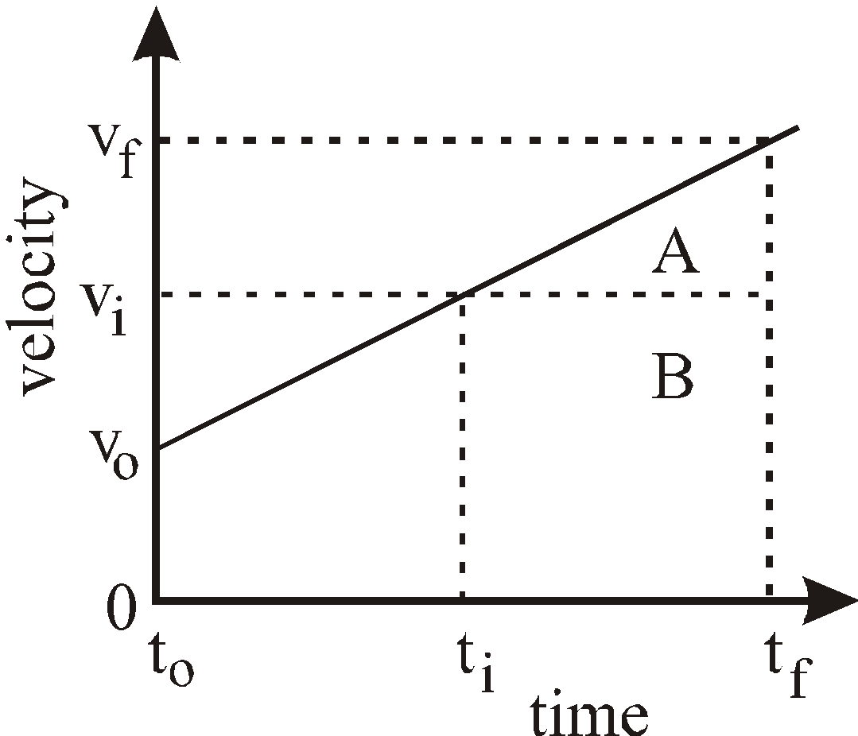

Therefore,

$$\overset{⃑}{v_{f}}=\overset{⃑}{v_{i}}+(\overset{⃑}{a}×∆t)$$

This method for building next-v is identical to the way that next-x was built in Unit 2.

11. It is imperative that students be able to navigate freely and proficiently between the different representations that show changing motion. By the end of Unit 3, students should be able to generate a data table of position and/or velocity, a motion map, a differential function for position and/or velocity, a position-time graph, a velocity-time graph, and a verbal representation of the motion, if presented with any other representation.

# **Sequence**

1. Unit Primer — Contrasting ‘Fast’ and ‘Slow’ Constant Motion
2. Lab 1 — Inclined Rail Motion (high-tech version)
3. Lab 1 — Inclined Rail Motion (low-tech version)
4. Worksheet 1a, 1b, 1c — Non-Constant Velocity
5. Activity 1 — Pace Car
6. Lab 1 Extension — Speeding Up, Slowing Down
7. Class Discussion — Development of Kinematic Formulas
8. Worksheet 2 — Self-Driving Car
9. Activity 2 — Miniature Golf
10. Worksheet 3 — Uniform Acceleration Problems
11. Lab 2 — Free Fall
12. Activity 3 — Simulating Lunar Drop
13. Worksheet 4 - Free Fall Practice
14. Activity 4 — Rocket Lander Game
15. The Model So Far

## 

## Unit Primer — Contrasting ‘Fast’ and ‘Slow’ Constant Motion

### Apparatus

* Slow-moving tumble buggy
* Faster-moving tumble buggy

The instructional goal for this bridging activity is to tie Unit 2 concepts together and get students focused on “Fast” vs. “Slow” motion to prepare for accelerated motion. Begin by showing students a fast constant velocity car traveling parallel to a slow constant velocity car.

Ask: How does the representation for fast constant velocity car’s motion differ from a slow constant velocity car’s motion on a:

* motion map?
* position-time graph?
* velocity-time graph?
* next-x function?

Have students whiteboard and discuss their ideas for these four representations.

Highlight points:

* Students should recognize on the motion map, that the dots are wider spaced on the faster car than the slower car, and that the velocity vectors are longer for the faster car than for the slower car.
* Students should recognize on the position-time graph, that the slope of the fast car is steeper than the slope of the slow car.
* Students should recognize on the velocity-time graph, that the constant value of the fast car is higher than the value of the slow car.
* Students should recognize in the program that the value of the fast car’s velocity must be expressed as a larger number than the slower car.
* Students should be directed to pay particular attention to representations of delta-x.

Final prediction:

* Students should predict what they believe a velocity-time graph and motion map would look like if a slow-moving object gradually became a fast moving object.

## 

## 

## Lab 1 — Inclined Rail Motion (high-tech version)

*Note: An alternate low-tech version is included below.*

### Apparatus

* Dynamics cart
* Dynamics track
* Motion sensor/detector w/interface

### Pre-Lab Discussion

* Let the cart roll down the inclined track and ask students for observations. Record all observations. To proceed, they must mention something to the effect that the cart speeds up as it rolls down.
* To obtain a finer description, ask students which observations are measurable. They should include the observation that the cart speeds up as it rolls down the rail. (Do not let them state the ball accelerates since we have NOT defined acceleration yet!)
* Ask them how they can measure speed directly. Lead them to the conclusion that they cannot, but that we do have a tool that we have used to give us that data.

Focus Question: If the car is speeding up as we observe, then what do we predict the motion map, position-time graph, and velocity-time graph look like?

Have students work in their groups to offer up their predictions. As students may be reluctant to share their thoughts… draw their attention back to the Unit Primer… having a ‘slow’ car at the beginning of the motion… and a ‘fast’ car at the end of the motion.

### Lab Performance Notes

The motion sensor should be set at the top of the ramp, and ‘zeroed’ at the position the cart will be released from. This will allow students to record data for an object accelerating away from the zero position, in the positive direction. It is important that they mark this zero position on the track so they can easily return and collect more data if needed.

We *want* the students to see a moving object at the first data point. (This will alleviate the question of ‘accelerating while not in motion’ issue for the current moment and allow for that to be addressed at a later time.)

After collecting data, students should record the ‘clock reading’ and positions at 0.20 second intervals.

Post-Lab discussion for this lab is included in the low-tech version section below.

## 

## Lab 1 — Inclined Rail Motion (low-tech version)

The discussion below is predicated on the use of the wheel and axle on rail apparatus in place of the dynamics cart and motion sensor outlined above. Using the wheel and axle on rail apparatus allows the object to accelerate very slowly, so students can easily mark its position as it rolls down the rails each ‘tick’, just as they did with the Tumble Buggy Lab from Unit 2. (This can be done as a video analysis, preferably with video taken from above with dynamics tracks.)

### Apparatus

Wheel (build from 4-inch hole saw cut-out, dowel, golf tees)[1]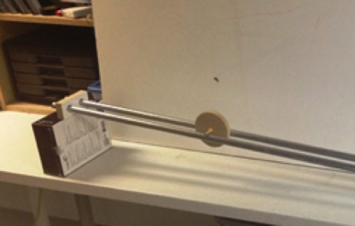

Track (two lengths of electrical conduit or dynamics tracks)

Masking tape

Metronome (real or virtual)

### Pre-Lab Discussion

Let a wheel roll down an inclined rail and ask students for observations. Record all observations. To proceed, they must mention something to the effect that the wheel speeds up as it rolls down.

To obtain a finer description, ask students which observations are measurable. Make sure they include the observation that the wheel speeds up as it rolls down the rail. (Do not let them state the wheel accelerates since we haven't defined acceleration yet!)

Ask them how they can measure speed directly. Lead them to the conclusion that they cannot, but that they can measure position and time. Note: Since this lab is so similar to the Unit 2 Buggy Lab, this should be a matter of review to most of them. Suggest that students should mark the position of the object at equal time intervals; again, time should be plotted as the independent variable.

### Lab Performance Notes

Students should collect data clock reading and position data for the motion at 1 second intervals. The initial state should be taken as the axle is already in motion, to allow the v = 0, a ≠ 0 condition to be addressed in subsequent lessons. Students should select a time interval that makes sense to allow for 7-10 data points.

### Post-Lab Discussion

The students should whiteboard their data table and draw a motion map for the data from the lab. Have them discuss the differences they see from the last unit. (If you do the low-tech version and your students have suspect data, you may want to have them go on to WS 1a for this analysis.)

Possible discussion questions:

* What does the increase in spacing between the dots mean?
* What should happen to the velocity arrows for successive clock readings?
* How does your motion map indicate the object is speeding up?

Using the motion map, draw a position vs time graph for your data. (Depending on your students you may want to call back to unit 2 when we flipped the motion map to get position data for the graph.)

This activity leads directly into Worksheet 1a, 1b, 1c.

## 

## Worksheet 1a, 1b, 1c — Non-Constant Velocity

### Resources

* Unit 3 Worksheet 1a: Non-Constant Velocity
* Unit 3 Worksheet 1b: Non-Constant Velocity
* Unit 3 Worksheet 1c: Non-Constant Velocity

Worksheet 1a - *Instructional Goal* - Midpoint Rule: for a position-time graph, the velocity at the midpoint of a time interval can be approximated by finding the average velocity over the time interval, meaning the instantaneous velocity at the midpoint of an interval can be approximated as the change in position divided by the change in time for the interval itself.

Students will have difficulty finding instantaneous velocities, as they can’t find the slope of a single point. Since tangent lines could be an issue with students at this point as well, worksheet 1a will walk them through the idea that the slope of a line drawn from equal time-values away from a target clock reading will all have the same slope, i.e. tangent at 3.0 seconds can be approximated by using the chord from t = 0s to t = 6s, t = 1s to t =5s, t = 2s to t = 4s, etc. This slope is the *average velocity* for this time interval. As the line gets closer to the target value, they should imagine a line that has the same slope but only touches the curve at one point. They need to figure out that this point has that velocity only at that moment. A term that we will call the velocity at that particular clock reading or *instantaneous velocity*.

BIG IDEA: The average velocity approaches the instantaneous velocity as the time interval shrinks to 0.

Worksheet 1b – *Instructional Goal* – Using the midpoint rule from 1a, students should be able to create a data table and then graph a velocity v. time graph that matches the position v. time graph.

Worksheet 1c - *Instructional Goal* - Students will build the velocity-time graph based on the use of the Midpoint Rule as outlined in Worksheet 1b. When reaching question 7, students should be reminded of the ‘smoothing’ process of the next-x function from Unit 2. Specifically, they can *start* with the function:

**fun** next-v(v):

v + delta-v

**end**

But, as with the *next-x* function in Unit 2, changing *delta-t* has dramatically different results.

So, we want students to move towards:

**fun** next-v(v):

v + (a * delta-t)

**end**

The acceleration is also defined as the slope of the velocity graph (which is really just the ratio ∆v / ∆t ).

Students should now revisit their motion maps. The increasing space between consecutive dot placements should illustrate to students that the velocity is also increasing from dot to dot. Once this relationship has been established, students should be directed to check the velocity-time data table and label the velocity for each clock reading of data (previously defined as *instantaneous velocity* in 1a)*.* Have students determine the change in velocity from one time to the next.

t = 0

t = 1

t = 2

t = 3

v

v + (a * ∆t)

v1 =

v2 =

v3 =

v1 + (a * ∆t)

v2 + (a * ∆t)

(a * ∆t)

a

a

a

a

This mirrors the next-x activity from Unit 2. Students should recognize that the change in velocity between dots is a constant value. Pictorially, the next-v vector is the sum of the current-v vector plus a change in velocity vector.

The motion map representation can now include a vector for acceleration that shows the change in velocity associated with each clock reading. This means that, for an object moving with a uniform acceleration, the acceleration vectors will be equal in both magnitude and direction.

The graphic below shows the connection between motion maps and v-t graphs with a uniform acceleration.

Continuing the ‘next-x’/‘next-v’ connection, the students will need to ‘generalize’ the ‘change in velocity’ value to the acceleration * delta-t calculation, like was done for the next-x function in Unit 2 Activity 2 - Advanced Simulated Motion. The change in velocity is dependent on the time interval chosen and students will need to make this connection.

Students should use the best-fit line for this graph to determine the best-fit line equation and the next-v function. The next-v function should be drawn out of a whiteboard discussion.

Ask students to extend the velocity-time table to push them towards the next-v function definition, similar to how we used the position-time table in Unit 2 to define the next-x function.

Before moving away from the motion map they have just drawn, ask students… what would the motion map look like if we backed up the motion map by one tick (aka, t = -1 second).

t = 0

t = 1

t = 2

v =

v + (a * ∆t)

v1 =

v2 =

v1 + (a * ∆t)

0 + (a * ∆t)

0

a

a

a

a

We want students to see that in order for our velocity to change *from* 0 m/s, there *must be* an acceleration, so that in the next tick there is some velocity present equal to: “0 + (a * ∆t). We can develop this as we move from a velocity of 0 m/s to 8 m/s, to 16 m/s, etc. as the acceleration value was 8 m/s every second.

## Activity 1 — Pace Car

### Resources

* Unit 3 Activity 1: Pace Car
* Student Code: <https://tinyurl.com/U3-Pace-Car>

### Performance Notes

In the previous unit, we defined next-x(x, v) as:

**fun** next-x(x, v):

x + (v * delta-t)

**end**

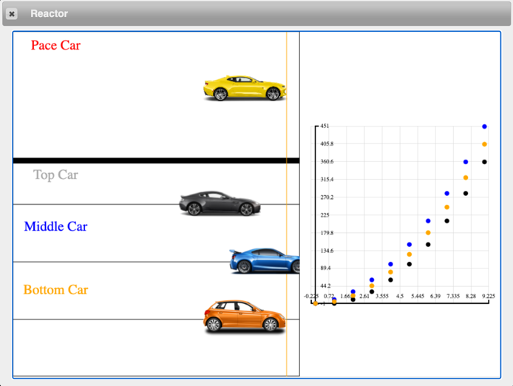The central question of this activity for students is: Now that we are exploring objects with a changing velocity, *which* velocity should we provide as the argument for next-x, in order to accurately predict the position at the next tick? Should we use the velocity *at that same clock reading* (v), like we did in for objects with constant motion? Should we use the velocity *at the next clock reading* , meaning next-v(v)? Or should we use some other velocity that is neither of those?

In this activity, students will see a pace car whose motion is similar to the uniformly accelerating object in Lab 1. *It should be communicated to students that the functions to control the motion of this car exist in the background.* The role of the students is to write the functions that control the motion of the three cars below the pace car. They will be examining three possible methods of doing so.

Students will begin the activity by testing the next-v function written in Worksheet 1c. It should be noted that this function will change the velocity of all three cars below the pace car. At this point, they have communicated how to change the velocity of the cars, but not how to change the position of the cars, *so none of the three will move*.

The three position functions will guide students to understanding that using the current velocity produces *too little* change in position, using the next velocity produces *too much*, and using a combination of the two, the average velocity, produces *just the right amount* of displacement*.*

Each function will begin as a table of positions, prompting students to calculate examples that can then be used in the examples block of each function.

The function next-x-top consumes the current position and velocity and produces the next position. Students will first complete the table of positions, following the pattern highlighted in the table. A Function Design can then be used to design the next-x-top function, following the same pattern from the table.

One possible idea for a whiteboard extension would be to use the table of position values to construct a *quantitative* motion map, comparing this with the motion of the pace car. Students should observe that the motion of the top car does not match the motion of the pace car, possibly stating that it falls behind or fails to keep up. The same can be done for the middle and bottom cars.

The next-x-middle function also consumes the current position and velocity and produces the next position of the car. The key difference is that this function uses the *next* velocity in the calculation. Students will again follow the pattern in the table to first calculate values and use this to determine a pattern. A Function Design can then be used to design the next-x-middle function.

One new idea in writing the next-x-middle function is that, since next-v itself is an *identifier defined to be a function*, students must use the function notation next-v(v).

**fun** next-x-middle(x, v):

x + (next-v(v) * delta-t)

**end**

Students should note that using the next velocity again produces motion that does not match that of the pace car, this time stating that the middle car moves ahead of the pace car. Since they have observed that using the current velocity produces too little change in position, and using the next velocity produces too much change in position, their final task is to use a velocity that produces a change in position someplace in between these two.

The next-x-bottom function consumes the current position and velocity of the car and produces the next position, using the average velocity in the calculation. Students will, one final time, follow the pattern in the table to produce a table of position values. Since the simulation outputs a table of position values for the pace car they may notice that using the average velocity results in the same positions as those they have already seen in the simulation.

Students must include a calculation for average velocity within the expression. In this example, comments are included to indicate to the person reading the code how the average velocity is calculated.

**fun** next-x-bottom(x, v):

# average velocity is the average of v and next-v(v)

# v-avg = ((v + next-v(v)) / 2

x + (((v + next-v(v)) / 2) * delta-t)

**end**

*Note: In all future simulations, the calculation of average velocity will be part of the background code. It is recommended that the arguments for next-x be expressed as position and* ***average*** *velocity, as illustrated below. The programming piece of this allows for students to eventually deal with NON-constant accelerations in Unit 5, without revisiting the functions for either next-x or next-v to adjust them to these changes. Without moving this calculation to the background, the next-x function would need to be constantly enlarged to bring in more and more arguments, as would next-v. The next-x functions will consistently be the following in all future simulations.*

**fun** next-x(x, v-avg):

x + (v-avg * delta-t)

**end**

**fun** next-v(v, a):

v + (a * delta-t)

**end**

## Lab 1 Extension — Speeding Up, Slowing Down

### Resources

* Unit 3 Lab 1 Extension: Speeding Up, Slowing Down

### Apparatus

* Dynamics cart
* Dynamics track
* Motion sensor/detector w/interface

*Note that the apparatus used here is the same as the one used in Unit 3 Lab 1 (high-tech version).*

### Pre-Lab Discussion

Make sure students understand the format of the lab, that they are now examining the motion of the cart with varying initial positions and directions of motion. They are to observe the motion and then draw a motion map and predicted graphs. Then the students check their graph predictions using the motion detector.

It may be helpful to show students how to resize the graph axes so students can focus on the relevant portions of the graph. Analysis should focus on the region of the graph in which the cart is coasting and not on initial pushes or final stops.

### Lab Performance Notes

Students should be instructed to display the x-t, v-t, and a-t graphs on the same screen, preferably stacked so that the same clock reading can be read vertically from one graph to the next. Show students how to zero the motion detector and remind them to do this when they change its placement. Situation 6 requires students to place the zero position in the middle of the track. This forces students to confront the fact that the sign of the change in position, not position itself, determines the sign of the velocity.

### Post-Lab Discussion

Use the whiteboard session to reinforce connections between the actual motion, the description of the motion, the motion map and the x-t, v-t and a-t graphs.

It may be helpful to refer to a pencil as a “slope indicator” and have students hold the center of the pencil tangent to various places on the curve. The slope of the pencil is the instantaneous velocity on the x-t graph, and the instantaneous acceleration on a v-t graph. Moving the pencil along the curve on the graph and observing how the slope of the tangent changes can help students to see how the velocity or acceleration changes.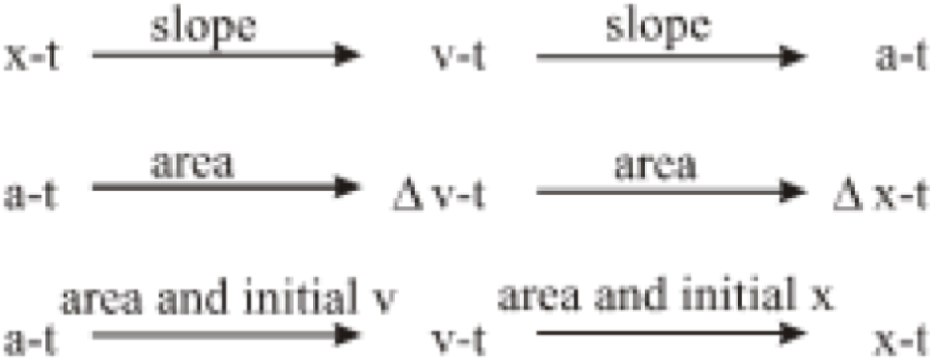

Questions on the relations between graphs can be based on the following summary from the [PSSC text](https://en.wikipedia.org/wiki/Physical_Science_Study_Committee):

|  |  |  |
| --- | --- | --- |
|  | Positive Direction | Negative Direction |
| Speeding Up | v (m/s)  t (s)  x (m) | x (m)  v (m/s)  t (s) |
| Slowing Down | v (m/s)  t (s)  x (m) | x (m)  v (m/s)  t (s) |

## Class Discussion — Development of Kinematic Formulas

Instructional Goal: Discover the kinematic equations from a generalized velocity-time graph

*Note: While students have the graphical representations needed to solve kinematics problems, this development provides them with an additional algebraic representation. It can be omitted for those wanting to maintain a purely graphical problem-solving approach.*

$\overset{⃑}{a}≡\frac{∆\overset{⃑}{v}}{∆t}$ Eq. 1 definition of average acceleration

$\overset{⃑}{v_{f}}=\overset{⃑}{v_{0}}+\overset{⃑}{a}t$ Eq. 2 linear equation for a v-t graph

$\overset{⃑}{v_{f}}=\overset{⃑}{v_{i}}+\overset{⃑}{a}∆t$ Eq. 3 generalized equation for any $t_{i}$ to $t_{f}$ interval

$\overset{⃑}{x_{f}}=\overset{⃑}{x_{0}}+\overset{⃑}{v_{0}}t+\frac{1}{2}\overset{⃑}{a}t^{2}$ Eq. 4 parabolic equation for an x-t graph

$\overset{⃑}{x_{f}}=\overset{⃑}{x_{i}}+\overset{⃑}{v_{i}}∆t+\frac{1}{2}\overset{⃑}{a}(∆{t)}^{2}$ Eq. 5 generalized equation for any $t_{i}$ to $t_{f}$ interval

${\overset{⃑}{v_{f}}}^{2}={\overset{⃑}{v_{i}}}^{2}+2\overset{⃑}{a}∆\overset{⃑}{x}$ Eq. 6 algebraic combination of equations 3 and 5

We have already discussed, in the Teacher Background section, where the kinematics equations come from, but we will now investigate this with the students.

* Present students with a ‘generic’ velocity versus time graph, as shown below.
* Ask students to rearrange Equation 1, and make it have the appearance of Equation 2, or have students use the graph below and have them determine the value of $v_{f}$ based on the values of $v_{i}$, $t_{i}$, $t_{f}$, and the slope of the graph (*a*).

*Reminder:  
Eq 1 - slope of v-t graph*

*Eq 2 - line of Best-Fit eq from v-t graph.*

Students should produce:

$\overset{⃑}{v_{f}}=\overset{⃑}{v_{i}}+\overset{⃑}{a}∆t$ (Equation 3)where $∆t$ is $t_{f}-t_{i}$.

This follows the pattern of Equation 2.

$\overset{⃑}{v_{f}}=\overset{⃑}{v_{0}}+\overset{⃑}{a}t$

Equation 5 comes out of the previous definition of displacement from Unit 2. Displacement is defined to be the area under the graph of velocity versus time. Using the graph above for velocity versus time, we can find the areas of both region B, and region A.

|  |  |
| --- | --- |
|  | Area of Region A  Area of a triangle = $\frac{1}{2} base ×height$ Which produces: $\frac{1}{2}(t_{f}-t_{i})×(\overset{⃑}{v_{f}}-\overset{⃑}{v_{i}})$ $\frac{1}{2}∆t×(\overset{⃑}{v_{f}}-\overset{⃑}{v_{i}})$    Since $\overset{⃑}{v_{f}}=\overset{⃑}{v_{i}}+\overset{⃑}{a}∆t$, the expression in parentheses can be written as $$\overset{⃑}{v_{f}}-\overset{⃑}{v_{i}}=\overset{⃑}{a}∆t$$ After substitution: $\frac{1}{2}∆t×\overset{⃑}{a}∆t$ Thus, the area of region A is $\frac{1}{2}\overset{⃑}{a}(∆t)^{2}$ |
| Area of Region B  Area of a rectangle = $length × width$ Which produces: $(t_{f}-t_{i})×\overset{⃑}{v_{i}}$ $$∆t×\overset{⃑}{v_{i}}$$ Thus, the area of region B is $\overset{⃑}{v_{i}}∆t$ | Areas of Regions A + B  The total area would be the sum of these two. $$∆\overset{⃑}{x}=\frac{1}{2}\overset{⃑}{a}(∆t)^{2}+\overset{⃑}{v_{i}}∆t$$ or $$\overset{⃑}{x_{f}}=\frac{1}{2}\overset{⃑}{a}(∆t)^{2}+\overset{⃑}{v_{i}}∆t+\overset{⃑}{x_{i}}$$ |

## 

## Worksheet 2 — Self-Driving Car

### Resources

* The student code can be found at <https://tinyurl.com/U3-Self-Drive>.
* Unit 3 Worksheet 2: Self-Driving Car

This activity will illustrate a real-life scenario in which a self-driving car must be programmed to appropriately stop at a stop sign, according to the rules of the road. On this worksheet, students will focus on the area of the velocity versus time graph. The culminating activity will be a simulation in which students will program the conditions for where the car must start braking to follow the rules of the road.

Students should be directed to work through the first 2 pages of the worksheet before having a share-out whiteboarding session. Then, students should be directed to work through page 3, and again have a whiteboarding session. Focus attention on the ability to determine the displacement of this car, without knowing the time required for it to stop. Discuss alternative solution paths.

Before proceeding to the simulation of the Self-Driving Car approaching a stop sign, students should complete the function design for the should-brake function.

In this simulation, students have multiple tasks before them:

Step 1: The starter code defines the should-brake function to always return true, which will ensure the car is braking the entire time. Students will determine the maximum (*magnitude only*) acceleration of the self-driving car using the output table from running the sim as is.

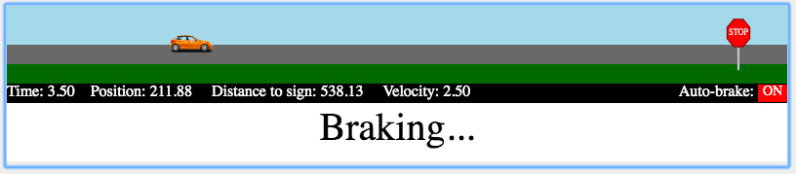

Step 2: Students will then *revise* the should-brake function to stop the car (using a Boolean operator… e.g., <, >, ==, >=, <=, <> ). The last few questions from the worksheet can help guide students to the general form expression for the distance from the stop sign for the program to ‘turn on’ the brakes. This expression, comparing two sides using a Boolean operator, is a Boolean expression.

Start this revision with the velocity-time graph. Students will need to determine two expressions: one for the displacement of the car as it brakes, and another for the displacement of the car between the tick when it takes in the information and the tick when the brakes are applied. The Boolean expression should compare the distance to the stop sign and the total displacement of the car.

The Function Design with Booleans will be used to create the should-brake function. The examples can be expanded to include *named* examples blocks. These names will be used in any feedback received to make identifying failed examples easier.

**examples** "should brake, aka true"**:**

should-brake( ) **is** true **because** ________________________

should-brake( ) **is** true **because** ________________________

**end**

**examples** "should NOT brake, aka false"**:**

should-brake( ) **is** false **because** _______________________

should-brake( ) **is** false **because** _______________________

**end**

In this simulation one examples block has been named with the string “should brake, aka true” and the examples in this block use expressions that will evaluate to true. The second examples block has been named with the string “should NOT brake, aka false” and the examples in this block use expressions that evaluate to false. This encourages students to include examples for both braking and not braking situations, otherwise they could just write a function that *always* brakes.

When the examples block is checked in comparison to the function block, the check includes a *left side*, a *right side*, and an *explanation*. The *left side* evaluates the function using the example inputs. The *right side* of the example is the Boolean value of true or false stated after the **is**. The *explanation* is the Boolean expression, using the example inputs, written after the **because**. To pass all tests the left side, right side, and explanation should all evaluate to the same Boolean value.

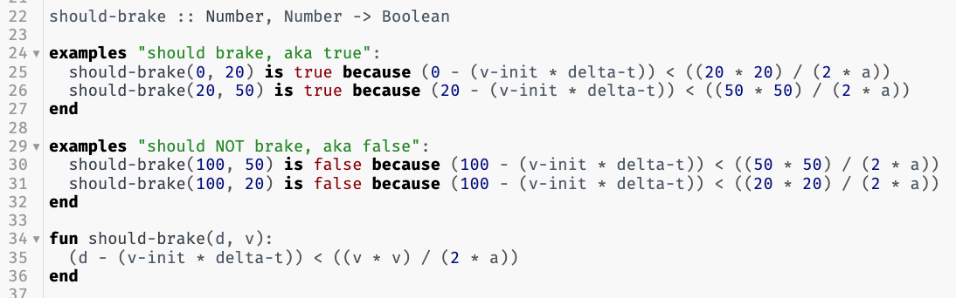Sample Solution:

Pyret treats the “<” symbol like any other operator, so be sure to use parentheses around the *left* side of the comparison and the *right* side of the comparison, when necessary, as you would in any expression that combines multiple distinct operators.

Step 3: Students will need to test their braking function using the last line of code. Students should *uncomment* (remove the hashtag from) the last line of code. True success is measured by the same exact program to successfully stop the car near the stop sign, repeatedly, without any changes in between trials. Three different *random* initial positions and initial velocities will be tested in succession, so that students can’t overfit their code to the initial scenario (e.g., by using a constant value instead of a more flexible expression).

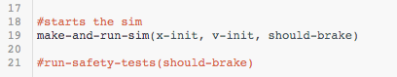

## Activity 2 — Miniature Golf

### Resources

* Unit 3 Activity 2: Miniature Golf
* Student Code: <https://tinyurl.com/U3-Mini-Golf>

Students will choose (arbitrarily at first) where the golf ball starts and will choose (also arbitrarily) how fast to hit the ball. This first attempt should be considered a *test case*. Students should use the test case to learn about the simulation. Students will need to use the output table of data provided by Pyret to learn about the putting green, then adjust the initial position and/or the initial velocity to score on the next try.

Students must write the next-x function. This follows the same pattern as Unit 2, with the change of using v-avg rather than v. Remind students that the calculation for v-avg is now included in the background so they need not define it.

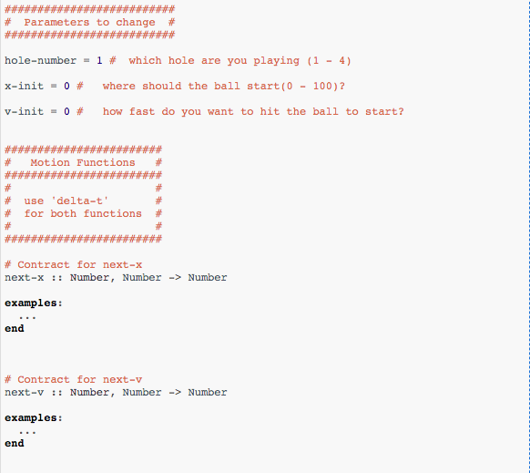Students should be challenged to reach the hole within two tries. The first is for data gathering purposes, and no one is expected to get the ball in the hole successfully on their first shot. However, the output includes a table of data and should be sufficient for students to determine the necessary information to be successful at getting a hole-in-one on the second shot. After they get a hole-in-one, students should change the initial position of the ball and repeat the process.

*Note: the* next-v *function in this simulation requires the acceleration as an argument for the function in addition to the velocity. Developing this format for the function* next-v *follows the same process as when the second argument was added to the* next-x *function.*

A final challenge in the activity asks students to predict which of the 4 tested surfaces has the longest grass and be able to provide reasoning for their answer. Students should be advised to record their initial conditions for each putting green, to help in determining the ‘longest grass.’

Students will examine each green by changing the hole number to indicate which hole they are investigating.

## Worksheet 3 — Uniform Acceleration Problems

### Resources

* Unit 3 Worksheet 3: Uniform Acceleration Problems

This worksheet contains ‘standard’ kinematics problems that can be solved using either velocity-time graphs or the derived kinematics formulas. Since the emphasis thus far has been on the graphical representation, students should be encouraged to solve these problems using the graphical method. Velocity-time axes are provided to aid in the graphical solutions.

## 

## Lab 2 — Free Fall

### Resources

* Veritasium: “Can You Perceive Acceleration?” <https://www.youtube.com/watch?v=YJbKieEC49M>
* Apollo 15 Hammer and Feather video (original, with audio) <https://www.youtube.com/watch?v=oYEgdZ3iEKA>
* Unit 3 Lab 2: Free Fall

### Apparatus

* Small falling object (e.g. golf ball)
* Solid color (in contrast to falling object) background for video
* Meter stick (or any object of known length to use for scaling the video)
* Video capture device (iPad, cell phone, etc.)
* Vernier Video Analysis[2] (or similar) video analysis software

### Pre-Lab Discussion

Start by watching the Veritasium video, “Can You Perceive Acceleration?” and have students compare the two methods for viewing motion that are presented.

Drop the golf ball from shoulder height. Students should observe the golf ball fall to the floor, then whiteboard a corresponding motion map with their group (until just before the ball bounces).

### Lab Performance Notes

Perform the lab ahead of time and have a suitable video to use if students cannot create their own.

Students will secure the scaling device at the same distance from the camera as the dropped ball, to reduce potential parallax error.

Once the video is filmed, the video can be opened within the video analysis software and position versus time data can be plotted, as well as velocity versus time data. Clicking through the video frame by frame is tedious and time consuming. Instead, students can skip a few frames along the way focusing only on the motion of the full drop as best as possible.

### Post-Lab Discussion

Use the worksheet to guide student thinking through the analysis process. This worksheet should be worked on in class within student lab groups rather than assigned as homework where students work on it independently.

***After question 5***, students will watch the video of Apollo 15 astronaut David Scott dropping a hammer and a feather on the surface of the Moon. This video should be watched with accompanying audio, as he explains what he is doing and speaks of the findings of Galileo and how they relate to his impromptu experiment.

The goal of watching this video is to illustrate that all objects fall with the same rate of acceleration when in the same gravitational field and in the absence of air resistance and to set up students for the next activity, in which they will use the same video as the backdrop for their own computational representation. As such, the name for the acceleration of a falling object in the absence of air resistance for this course will be *Galileo’s constant* (which is unique to each large astronomical object, such as planets or moons). Obviously, we cannot mandate such a change, but it is highly recommended to *not* refer to it as so many textbooks do, as the ‘acceleration due to gravity.’ Alternatively, simply referring to it as the ‘freefall acceleration’ would be another option.

## 

## Activity 3 — Simulating Lunar Drop

### Resources

* Unit 3 Activity 3: Simulating Lunar Drop
* The student code can be found at <https://tinyurl.com/U3-Lunar-Drop>

This simulation begins with an animation that overlays a red dot on the hammer, and a blue dot on the feather. Students will watch the animation, make observations, and collect the data given in the output table.

Students will use the output table in a graphical analysis program, like the LoggerPro program just used, to mirror the analysis of their own video, with the goal to determine the acceleration of freefalling objects on the surface of the Moon.

Students will analyze the motion of both the feather and the hammer, based on each respective set of data in the table, to determine the acceleration of each object. Students should share their data with neighboring groups for comparison purposes.

After having determined the acceleration of free-falling objects on the Moon, students will be tasked with simulating the falling of an object on the Moon, to replicate the experiment conducted by astronaut David Scott.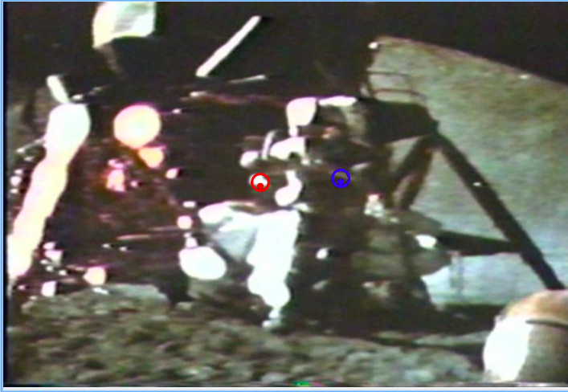

Students will use the Function Design to construct functions for next-y and next-vy, then type in their functions to move a ‘target circle’ around the falling objects. These functions for next-y and next-vy should be similar in structure to the functions for next-x and next-vx. *Students should be using the identifier name* v-avg *(or* vy-avg*) in their function for* next-y.

## Worksheet 4 - Free Fall Practice

### Resources

* Unit 3 Worksheet 4: Free Fall Practice

This worksheet gives students a chance to apply the current model for accelerated motion and the calculated “Galileo constant” to an object in free fall.

## Activity 4 — Rocket Lander Game

### Resources

* Unit 3 Activity 4: Rocket Lander Game
* Starter Code: <https://tinyurl.com/Rocket-Lander-Game>

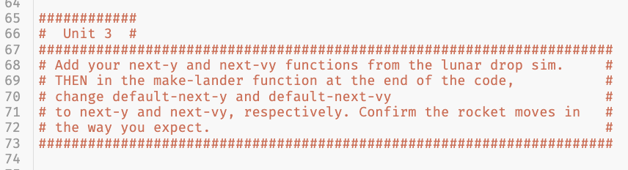At the conclusion of this unit students will be adding the next segment of code to their own video game. They previously wrote the program for an object moving with a uniform acceleration and will use the same format here.

For Unit 3, students will create the uniformly accelerated vertical motion for the rocket by writing the next-y and next-vy functions.

Once the function for next-y has been written in the appropriate location within the starter program, students need to change the input to the `make-lander` function at the end of the program from `default-next-y` to `next-y` so *their* function can be called, rather than the ‘default’. A similar process should be used for the function ‘next-vy.’

## The Model So Far

To summarize the unit, students should create “The Model So Far,” the current model for the motion of an object. The goal is to both review representations of motion and assess student understanding of the current model before progressing to forces.

# **Resource Index**

1. Unit 3 Worksheet 1a: Non-Constant Velocity
2. Unit 3 Worksheet 1b: Non-Constant Velocity
3. Unit 3 Worksheet 1c: Non-Constant Velocity
4. Unit 3 Activity 1: Pace Car
5. Unit 3 Lab 1 Extension: Speeding Up, Slowing Down
6. Unit 3 Worksheet 2: Self-Driving Car
7. Unit 3 Activity 2: Miniature Golf
8. Unit 3 Worksheet 3: Uniform Acceleration Problems
9. Unit 3 Lab 2: Free Fall
10. Unit 3 Activity 3: Simulating Lunar Drop
11. Unit 3 Worksheet 4: Free Fall Practice
12. Unit 3 Activity 4: Rocket Lander Game
13. Function Design with Extended Examples

#### **Unit 3 Worksheet 1a: Non-Constant Velocity**

|  |  |  |
| --- | --- | --- |
| 1. In the table at right are position-time data for a cart rolling down a track. Create a motion map for this motion and then plot a position vs. time graph and sketch a smooth curve through the points. | $t$ (s) | $\overset{⃑}{x}$ (cm) |
| 0.0 | 6.0 |
| 1.0 | 18.0 |
| 2.0 | 38.0 |
| 3.0 | 66.0 |
| 4.0 | 102.0 |
| 5.0 | 146.0 |
| 6.0 | 198.0 |

2. What is the physical significance of the slope of a position vs. time graph?

3. What is happening to the slope of your position vs. time graph as time goes on?

4. Explain what your answers to questions 2 and 3 tell you about the motion of the cart.

5. On the position vs. time graph, draw a line which connects the point at t = 0 to the point at t = 6.0 s.

6. Calculate the slope of this line in the space below. Explain what the slope of this line tells you about the motion of the cart.

|  |  |
| --- | --- |
| Slope Calculation: | Explanation: |

7. On the position vs. time graph, draw a line which connects the point at t = 2.0 s to the point at t = 4.0 s.

8. Calculate the slope of this line in the space below. Explain what the slope of this line tells you about the motion of the cart.

|  |  |
| --- | --- |
| Slope Calculation: | Explanation: |

9. On the position vs. time graph, draw a line tangent to the graph at t = 3.0 s.

10. Calculate the slope of this line in the space below. Explain what the slope of this line tells you about the motion of the cart.

|  |  |
| --- | --- |
| Slope Calculation: | Explanation: |

11. Compare the slopes you have calculated in questions 6, 8, and 10. Summarize the results of your comparison.

#### **Unit 3 Worksheet 1b: Non-Constant Velocity**

1. Use the position vs. time data to complete the data table below.

|  |  |  |  |  |  |
| --- | --- | --- | --- | --- | --- |
| $$t$$ | $$\overset{⃑}{x}$$ | $$∆t$$ | $$∆\overset{⃑}{x}$$ | $$t_{mid}$$ | $$\overset{⃑}{\overline{v}}$$ |
| (s) | (cm) | (s) | (cm) | (s) | (cm/s) |
| 0.0 | 6.0 |  |  |  |  |
|  |  | 1.0 | 12.0 | 0.5 | 12.0 |
| 1.0 | 18.0 |  |  |  |  |
|  |  |  |  | 1.5 |  |
| 2.0 | 38.0 |  |  |  |  |
|  |  |  |  |  |  |
| 3.0 | 66.0 |  |  |  |  |
|  |  |  |  |  |  |
| 4.0 | 102.0 |  |  |  |  |
|  |  |  |  |  |  |
| 5.0 | 146.0 |  |  |  |  |
|  |  |  |  |  |  |
| 6.0 | 198.0 |  |  |  |  |

1. Using the completed table, plot a velocity vs. time graph on the axes below. Use the last two columns of your data table as your data points.

#### **Unit 3 Worksheet 1c: Non-Constant Velocity**

1. Using the graph you created in Worksheet 1b, draw a line of best fit for your data points. Using that line, find the velocity of the object at each clock reading in the table.

|  |  |
| --- | --- |
| $$t (s)$$ | $$\overset{⃑}{v} (cm/s)$$ |
| 0.0 |  |
| 1.0 |  |
| 2.0 |  |
| 3.0 |  |
| 4.0 |  |
| 5.0 |  |
| 6.0 |  |

1. By how much does the velocity change each second?

|  |  |
| --- | --- |
| 7.0 |  |
| 8.0 |  |
| 9.0 |  |
| 10.0 |  |

1. Extend the velocity table to the right.
2. Fill in the velocity table to the right for clock readings separated by 0.5 seconds.

|  |  |  |
| --- | --- | --- |
| $t$ (s) | $\overset{⃑}{v}$ (cm/s) | Ratio of $Δ\overset{⃑}{v} /Δt$ |
| 5.0 |  |  |
|  |
| 5.5 |  |
|  |
| 6.0 |  |
|  |
| 6.5 |  |
|  |

1. Fill in the velocity table to the right for clock readings separated by 2.0 seconds.

|  |  |  |
| --- | --- | --- |
| $t$ (s) | $\overset{⃑}{v}$ (cm/s) | Ratio of $Δ\overset{⃑}{v} /Δt$ |
| 4.0 |  |  |
|  |
| 6.0 |  |
|  |
| 8.0 |  |
|  |
| 10.0 |  |
|  |

1. What pattern do you notice? Is there a common ratio of change in the velocity to the delta-t? What is this ratio? What are units for this ratio? This ratio you calculated has a name that we call **acceleration**.
2. Using a Function Design, design a function next-v that will consume the current velocity of an object and produces the velocity at the next tick. *Hint: This should work for any value of delta-t.*
3. Once you have designed a function go to code.pyret.org/editor to test your code for feedback.

#### 

#### 

#### **Unit 3 Activity 1: Pace Car**

In this activity, your goal is to compare the motion of three vehicles to the motion of a pace car. You will write functions to control the motion of each vehicle.

1. Open the activity starter code at <https://tinyurl.com/U3-Pace-Car>. Using the Function Design from Worksheet 1c, complete the next-v function and click “Run.” What do you notice?
2. The table below shows the velocity of the pace car for a set of clock readings. Determine the displacement of the top car and use this to determine the next position.

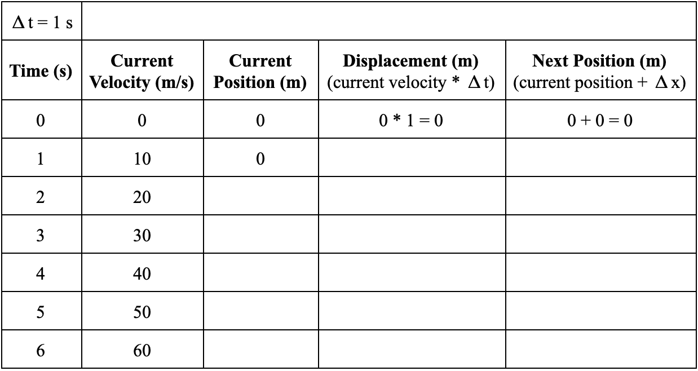

1. Using a Function Design, write a function called next-x-top, which consumes the current position and velocity of the top car and produces its position at the next tick.
2. Type in your next-x-top function and click “Run.” What do you notice?
3. The table below shows the velocity of the pace car for a set of clock readings. Determine the displacement of the middle car and use this to determine the next position.

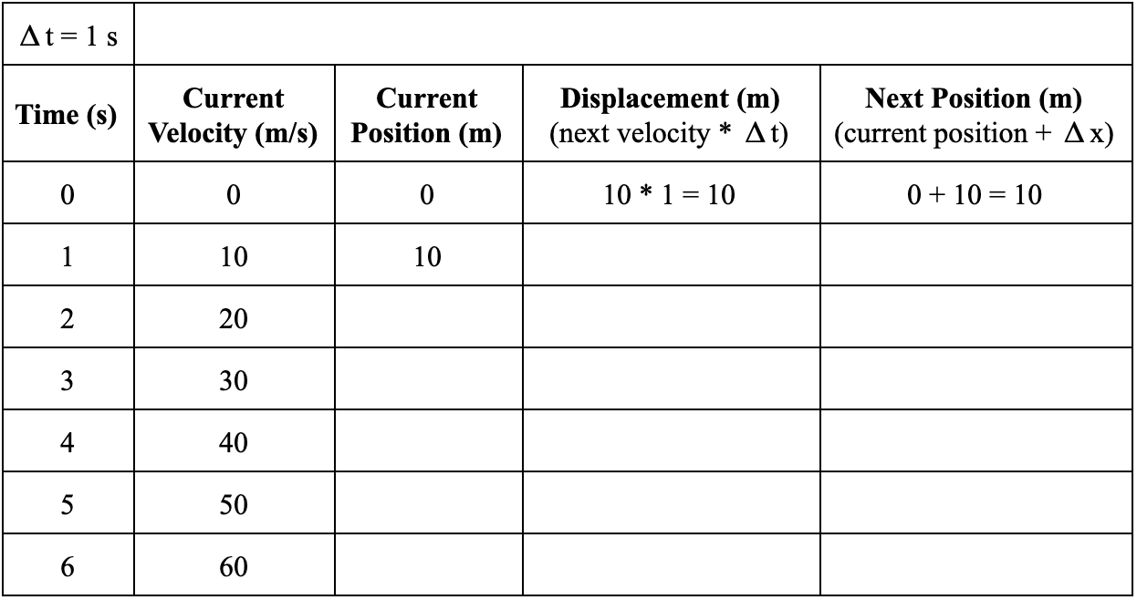

1. Using a Function Design, write a next-x-middle function which consumes the current position and velocity of the middle car and produces the next position using the *next* velocity in the calculation.
2. Type in your next-x-middle function and click “Run.” What do you notice?
3. How does the displacement for the middle car compare to the displacement of the top car? What does this mean in the simulation?
4. How could you determine a velocity that is *between* the current velocity and the next velocity?
5. The table below shows the velocity of the pace car for a set of clock readings. Determine the displacement of the bottom car and use this to determine the next position.

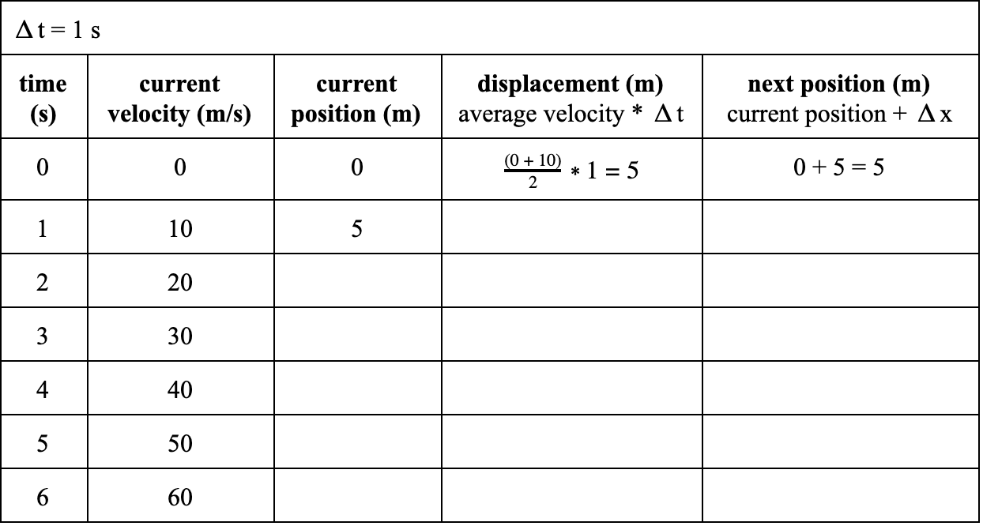

1. Using a Function Design, write a next-x-bottom function which consumes the current position and velocity of the bottom car and produces the next position using the *average* velocity in the calculation..
2. Type in your next-x-bottom function and click “Run.” What do you notice?

#### **Unit 3 Lab 1 Extension: Speeding Up, Slowing Down**

|  |  |
| --- | --- |
| **1. Speeding up, moving in the positive direction** | |
| a. Observe the motion of the cart starting from rest and rolling down the incline without using the motion detector. | |
| b. Draw a motion map including both velocity and acceleration vectors.  c. Is the velocity positive or negative? d. Is the acceleration positive or negative? | |
| e. Predict the graphs describing the motion. | f. Record the graphs as displayed by the motion detector. |
| g. On each observed graph in part f, describe the slope as  a) constant steepness, increasing steepness, or decreasing steepness  b) positive, negative or zero  c) state what the slope represents | |

|  |  |
| --- | --- |
| **2. Slowing down, moving in the positive direction** | |
| a. Observe the motion of the cart slowing after an initial push without using the motion detector. Answer the following questions for the cart while coasting. | |
| b. Draw a motion map including both velocity and acceleration vectors.  c. Is the velocity positive or negative? d. Is the acceleration positive or negative? | |
| e. Predict the graphs describing the motion. | f. Record the graphs as displayed by the motion detector. |
| g. On each observed graph in part f, describe the slope as  a) constant steepness, increasing steepness, or decreasing steepness  b) positive, negative or zero  c) state what the slope represents | |

|  |  |
| --- | --- |
| **3. Speeding up, moving in the negative direction** | |
| a. Observe the motion of the cart starting from rest and rolling down the incline without using the motion detector. | |
| b. Draw a motion map including both velocity and acceleration vectors.  c. Is the velocity positive or negative? d. Is the acceleration positive or negative? | |
| e. Predict the graphs describing the motion. | f. Record the graphs as displayed by the motion detector. |
| g. On each observed graph in part f, describe the slope as  a) constant steepness, increasing steepness, or decreasing steepness  b) positive, negative or zero  c) state what the slope represents | |

|  |  |
| --- | --- |
| **4. Slowing down, moving in the negative direction** | |
| a. Observe the motion of the cart slowing after an initial push without using the motion detector.  Answer the following questions for the cart while coasting. | |
| b. Draw a motion map including both velocity and acceleration vectors.  c. Is the velocity positive or negative? d. Is the acceleration positive or negative? | |
| e. Predict the graphs describing the motion. | f. Record the graphs as displayed by the motion detector. |
| g. On each observed graph in part f, describe the slope as  a) constant steepness, increasing steepness, or decreasing steepness  b) positive, negative or zero  c) state what the slope represents | |

|  |  |
| --- | --- |
| **5. Up and down the ramp** | |
| a. Observe the motion of the cart after an initial push without using the motion detector. Answer the following questions for the cart while coasting. | |
| b. Draw a motion map including both velocity and acceleration vectors.  c. Is the velocity positive or negative? d. Is the acceleration positive or negative?  Does the direction of the velocity change? Does the direction of the acceleration change? | |
| e. Predict the graphs describing the motion. | f. Record the graphs as displayed by the motion detector. |
| g. On each observed graph in part f, describe the slope as  a) constant steepness, increasing steepness, or decreasing steepness  b) positive, negative or zero  c) state what the slope represents | |

|  |  |
| --- | --- |
| **6. Up and down the ramp with a different zero position** | |
| a. Observe the motion of the cart after an initial push without using the motion detector. Answer the following questions for the cart while coasting. | |
| b. Draw a motion map including both velocity and acceleration vectors.  c. Is the velocity positive or negative? d. Is the acceleration positive or negative?  Does the direction of the velocity change? Does the direction of the acceleration change?  Is position A positive or negative? Is position B positive or negative? | |
| e. Predict the graphs describing the motion. Label points A and B on your x-t graph. | f. Record the graphs as displayed by the motion detector. |
| g. On each observed graph in part f, describe the slope as  a) constant steepness, increasing steepness, or decreasing steepness  b) positive, negative or zero  c) state what the slope represents | |

#### **Unit 3 Worksheet 2: Self-Driving Car**

While cruising along a dark stretch of highway with the cruise control set at 25 m/s ( ≈ 55 mph), you see, at the fringes of your headlights, that a bridge has been washed out. You apply the brakes and come to a stop in 4.0s. Assume the clock starts the instant you hit the brakes.

1. Construct a qualitative motion map that represents the motion described above, including position, velocity, and acceleration. Clearly demonstrate how you can determine the direction (sign) of the acceleration from the motion map representation.

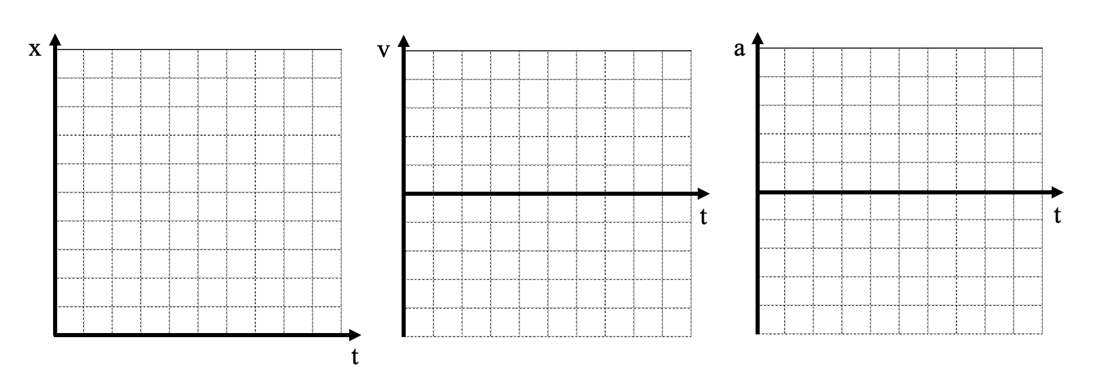

2. Construct **qualitative** graphical representations of the situation described above to illustrate:

a. x vs. t

b. v vs. t

c. a vs. t

3. Construct a **quantitatively** accurate v vs. t graph to describe the situation.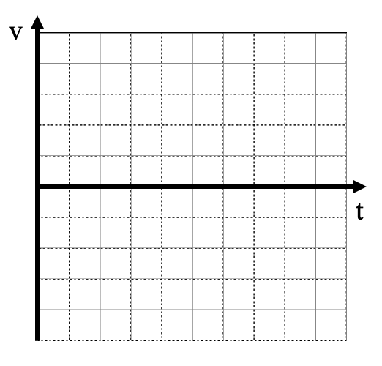

4. On the v vs. t graph at right, graphically represent the car’s displacement during braking.

5. Using the graphical representation, determine how far the car traveled during braking. (Please explain your problem solving method.)

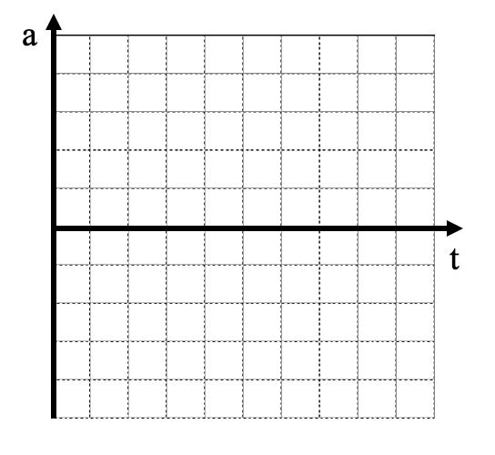

6. Determine the car’s acceleration. Then sketch a quantitatively accurate acceleration vs. time graph.

A car traveling down the highway at 35 m/s is able to accelerate at a *maximum* of 7 m/s/s when applying the brakes. *Be careful with the direction for the acceleration.*

7. Draw a **qualitative** velocity vs. time graph for the situation. How is the MINIMUM stopping distance represented on the graph? What information would be needed to determine the MINIMUM stopping distance?



8. Draw a **quantitative** velocity vs. time graph and determine the MINIMUM stopping distance.

9. How did you calculate the MINIMUM stopping time? Write a general form of this calculation that would work for any car.

10. What would change about your answer if the same car was moving at 40 m/s? What would change about your answer if the car was moving at 30 m/s? Sketch these changes on the velocity vs. time graph above.

11. Use the following URL to open the simulation: <https://tinyurl.com/U3-Self-Drive>

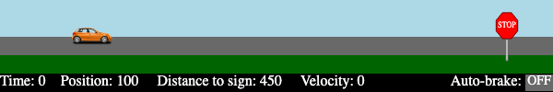

**First**, you will need to *run the simulation* and use the output table for the purpose of finding the acceleration to create a *smooth* acceleration to a stop. You will **then** write a function which *consumes* the distance to the stop sign and the velocity of the car and *produces* a Boolean that correctly tells the car to brake.

a = _______________________ # m/s/s

should-brake :: _______________________ -> ____________________

#_______________________________________________________________

#_______________________________________________________________

**examples** "should brake, aka true"**:**

should-brake( ) **is** true **because** ________________________

should-brake( ) **is** true **because** ________________________

**end**

**examples** "should NOT brake, aka false"**:**

should-brake( ) **is** false **because** _______________________

should-brake( ) **is** false **because** _______________________

**end**

**fun** should-brake( ):

_________________________________________________

**end**

#### **Unit 3 Activity 2: Miniature Golf**

4 different holes of mini-golf are provided. Each hole provides a different acceleration due to the length of the grass on the putting green. <https://tinyurl.com/U3-Mini-Golf>

Place the ball and provide an initial velocity for the ball from that location.

*(The ‘0’ position is the left side of the screen, and positive direction is defined as to the right.)*

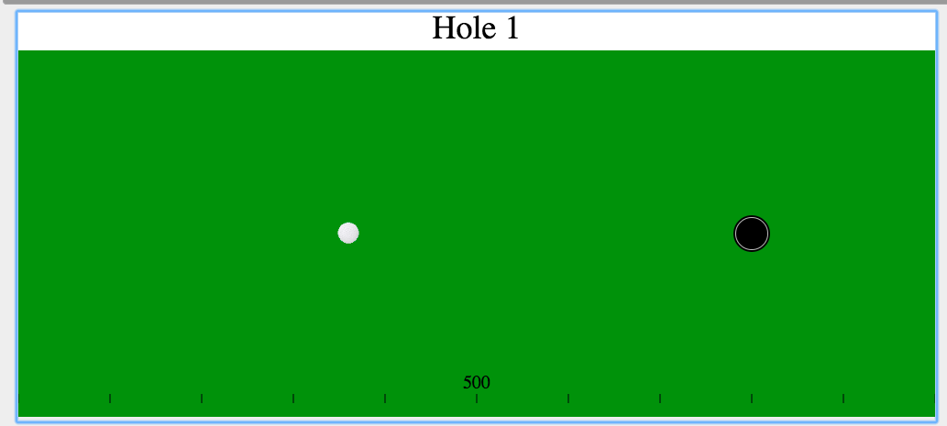

Beware:

* Too low a velocity and the ball won’t make it to the hole.
* Too high a velocity and the ball will skip right over the top.

For each hole, use the data table to determine an initial position and corresponding velocity to make the putt successfully. Every new putt will start over from the defined starting position, not from where the ball stops. Try to do it a second time with a different starting position!

|  |  |  |  |  |  |  |  |  |
| --- | --- | --- | --- | --- | --- | --- | --- | --- |
|  | Practice attempt | |  | Successful Attempt #1 | |  | Successful Attempt #2 | |
| Hole # | xinit | vinit |  | xinit | vinit |  | xinit | vinit |
| 1 |  |  |  |  |  |  |  |
| 2 |  |  |  |  |  |  |  |
| 3 |  |  |  |  |  |  |  |
| 4 |  |  |  |  |  |  |  |

Based on successfully completing all 4 holes:

Which green had the longest grass? What is the evidence of this?

#### **Unit 3 Worksheet 3: Uniform Acceleration Problems**

### 

1. A poorly tuned car can accelerate from rest to a speed of 28 m/s in 20 s.

1. What is the average acceleration of the car?
2. What distance does it travel in this time?



2. At t = 0, a car has a speed of 30 m/s.

At t = 6 s, its speed is 14 m/s.

What is its average acceleration during this time interval?



3. A bear spies some honey and takes off from rest, accelerating at a rate of 2.0 m/s2. If the bear runs for 4 seconds before reaching the honey, how far away was the hive?



4. A bus moving at 20 m/s (t = 0) slows at a rate of 4 m/s each second.

1. How long does it take the bus to stop?
2. How far does it travel while braking?

5. A physics student skis down a hill, accelerating at a constant 2.0 m/s2. If it takes them 15 seconds to reach the bottom, what is the length of their trip down the side of the mountain?



6. A dog runs down the driveway with an initial speed of 5 m/s for 8 s, then uniformly increases its speed to 10 m/s in 5 s.

1. What was the dog’s acceleration during the 2nd part of the motion?
2. How long is the driveway?



7. A mountain goat starts a rock slide and the rocks crash down the hill 100 m. If the rocks reach the bottom in 5 s, what is their acceleration?



8. A car whose initial speed is 30 m/s slows uniformly to 10 m/s in 5 seconds.

1. Determine the acceleration of the car.
2. Determine the distance it travels in the 3rd second. (t = 2s to t = 3s).

#### **Unit 3 Lab 2: Free Fall**

**Falling Objects**

1. Sketch the position vs time and the velocity vs time graphs in the space below.

y

vy

t

t

1. Do the graphs match your expectation of the motion of a falling object? Explain.

### 

1. What does the slope of the velocity versus time graph tell you?

1. What would happen if we dropped different objects? What if we dropped a coffee filter?

1. During the Apollo 15 Mission, while on the Moon, astronaut David Scott dropped a hammer and a feather at the same time. Predict what happened. Why do you think that?
2. After having watched the video, explain why that phenomenon happens on the Moon, but not the Earth.

1. What were the findings of Galileo, and what is the Law of Falling Bodies?

#### **Unit 3 Activity 3: Simulating Lunar Drop**

Open: <https://tinyurl.com/U3-Lunar-Drop>

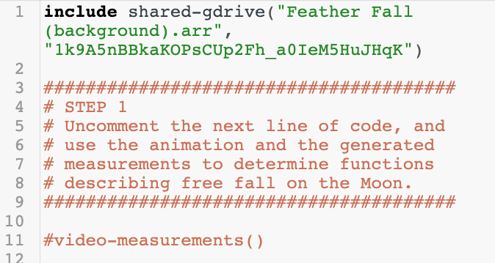

Uncomment line 11 to RUN the video analysis.

The video analysis, matching what you just did with your falling object on Earth, has been done for you. The data will be made available after the video is finished.

Your goal is to find the acceleration of a falling object on the Moon.



1. Copy and paste the data output into graphing analysis software.
2. Sketch the velocity-time graph on the provided set of axes to the right.
3. Determine the acceleration of each object dropped on the surface of the Moon. Show or explain how you determined this.

Simulating the situation:

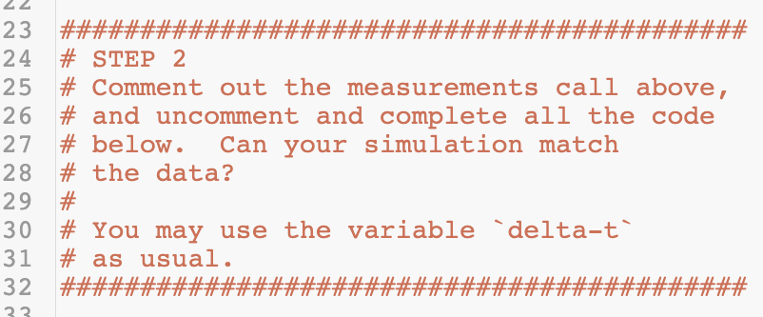

Add the comment back to line 11, then remove the `#|` from line 35 and the `|#` from line 59.

Use a Function Design provided by your teacher to determine how to write the functions for next-y and next-vy.

#### **Unit 3 Worksheet 4: Free Fall Practice**

1. On Earth, a rock is dropped off a cliff and is observed to splash into the ravine below, 4 seconds after it is released. How tall is the cliff?



1. How tall would a cliff on the Moon be, if a rock took 4 seconds to land on the surface?



1. If at a different cliff (on Earth), a rock were thrown down at 10 m/s and also took 4 seconds to splash at the bottom, how tall is the new cliff? Does this answer make sense to you? Explain.



1. A ball on Earth is thrown straight up at 45 m/s.
   1. How high does it reach?
   2. How long does it take to return to its original height?
   3. How fast is it moving as it reaches that height?
2. How would the answers to the questions in #4 change if these events were to take place on a different planet, specifically Mars (where the freefall acceleration value is ~ 4 m/s/s)?
3. 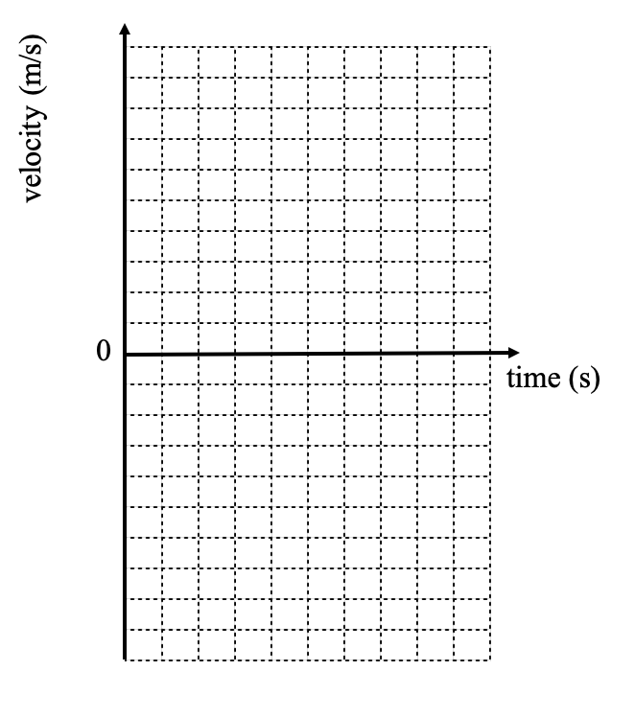On one set of axes, draw velocity-vs-time graphs for the following four scenarios:
4. a ball thrown with a small positive initial velocity on Earth
5. a ball thrown with a larger positive initial velocity on Earth
6. a ball thrown with a small positive initial velocity on the Moon
7. a ball thrown with a larger positive initial velocity on the Moon
8. What information is needed to appropriately label each of these graphs?
9. You decide to use Pyret to produce the graphs you just drew above. What information would *you need to provide* to the program, and what information *would it need to give back*, for you to generate these? (Is any of that information missing from the graphs above? Why or why not?)

#### 

#### **Unit 3 Activity 4: Rocket Lander Game**

Previously, you wrote a next-x function to move the rocket across the screen with a constant horizontal velocity. Now, your goal is to write two functions — next-y and next-vy — that cause the rocket to fall with a uniform acceleration to the surface of the planet.

1. Open your saved copy of the Rocket Lander Game. Look at the initial parameters at the beginning of the starter code. Which of these parameters might affect the vertical motion of the rocket? How would it affect the motion?
2. Find the following comment block:

############

# Unit 3 #

######################################################################

# Add your next-y and next-vy functions from the lunar drop sim. #

# THEN in the make-lander function at the end of the code, #

# change default-next-y and default-next-vy #

# to next-y and next-vy, respectively. Confirm the rocket moves in #

# the way you expect. #

######################################################################

1. Complete a Function Design for a next-y function that consumes the rocket’s current position and *average velocity between ticks* and produces the rocket’s position at the next tick. Once you have a completed Function Design, enter the Contract, Examples, and Definition for the next-y function below the comment above.
2. Complete a Function Design for a next-vy function which consumes the rocket’s current velocity and *a second argument* and produces the rocket’s velocity at the next tick. Once you have a completed Function Design, enter the Contract, Examples, and Definition for the next-vy function below the comment above.
3. Before you run the program, edit the last line to change `default-next-y` to `next-y` and `default-next-vy` to `next-vy`. Then run the program.
4. Reflect: Did you receive feedback? Did the code highlighted by the feedback message include your mistake? What did you need to do to make the program run as you intended?

#### 

|  |
| --- |
| **Function Design with Extended Examples** |

|  |
| --- |
| **Defined Identifiers** |

|  |  |  |  |  |
| --- | --- | --- | --- | --- |
|  | = |  |  | # |
| Identifier |  | Value |  | Units |
|  | = |  |  | # |
| Identifier |  | Value |  | Units |
|  | = |  |  | # |
| Identifier |  | Value |  | Units |

|  |
| --- |
| **Physical Interpretation** |
| What will the input(s) of your function be? _______________________ (ex: side length)  What will the units of each input be? ____________________________ (ex: meters)  What will the output be? ______________________________________ (ex: area)  What will the unit of the output be? _____________________________ (ex: square meters) |

|  |  |  |  |  |  |  |
| --- | --- | --- | --- | --- | --- | --- |
| **Contract and Purpose Statement** | | | | | | |
|  | | :: |  | -> |  |
| Function Name | |  | Domain (Input) Type(s) |  | Range (Output) Type |
| # |  | | | | | |
|  | What does the function do? (The function consumes ______ and produces _______.) | | | | | |

|  |  |  |  |  |  |  |  |  |  |
| --- | --- | --- | --- | --- | --- | --- | --- | --- | --- |
| **Examples** | | | | | | | | | |
| **examples:** | | | | | | | | | |
|  |  | ( |  | ) | **is** |  | **because** |  |
|  | Function Name |  | Example Input(s) |  |  | Expected Output |  | What calculation must be performed? |
|  |  | ( |  | ) | **is** |  | **because** |  |
|  |  | ( |  | ) | **is** |  | **because** |  |
| **end** | | | | | | | | | |

|  |  |  |  |  |  |  |
| --- | --- | --- | --- | --- | --- | --- |
| **Definition** | | | | | | |
|  |  |  |  |  |  |  |
| **fun** | ( ): | | | |  | |
|  | Function Name | | Input Name(s) |  | | |
|  |  | | | | | |
|  | What calculation must be performed with the named input(s) to produce the desired output? | | | | | |
| **end** | | | | | | |

1. Instructions found in AMTA Mechanics v.3, Unit 3 at <https://www.modelinginstruction.org/>
2. <https://www.vernier.com/product/video-analysis/>